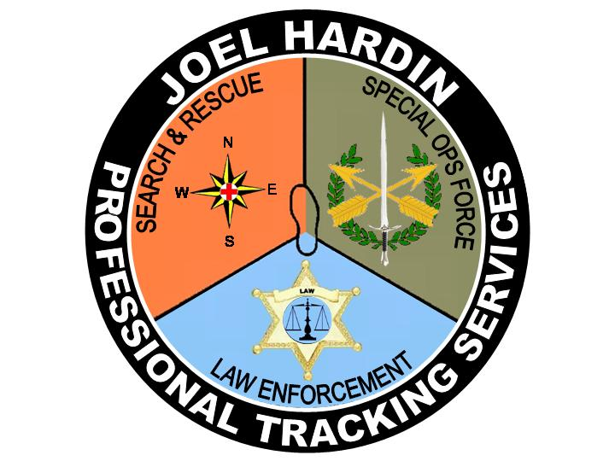
Tracking Step by Step... Joel Hardin Professional Tracking Services
225 Mill Road, Clearwater, Idaho 83552-5116 208-926-4390 joel@ jhardin-inc.com www.jhardin-inc.com
Phone: (360)966-7707
Email: Joel@jhardin-inc.com

2020 TRACKING COURSE ANNOUNCEMENT
TRAVERSE CITY, MICHIGAN

TRAINING OFFERED BY 3-FIRES TRACKERS – JHPTS –VISUAL TRACKING

LAW ENFORCEMENT EMPHASIS

5-DAY TRACKING TRAINING COURSE

Date: April 20 - 24, 2020

Time: 08:00 a.m., Monday, April 20, 2020 through 2:00 p.m., Friday, April 24, 2020

Location: YMCA Hayo-Went-Ha Camps, 1380 East Arbutus Lake Rd., Traverse City, MI 49686. This is a first class camp which houses up to 200 young people and counselors during the season from May to October.

Course Costs: made payable to JHPTS or PayPal account Joel@jhardin-inc.com
$250 for “sworn” Law Enforcement Officers
$450 for all other interested persons.

Tuition includes classroom materials and use of facilities all meals and dormitory bunk space. Students will arrive on Sunday, April 19th. Meals begin with breakfast Monday morning and end with lunch on Friday, April 24th before your departure.
A $100 deposit is required to reserve space in this professional tracking class and must be received prior to April 10th, 2020. Balance must be paid at registration. Bring your own sleeping bag or similar and toiletries including a towel.

Meals & Accommodations: Dormitory style accommodations are provided Sunday through Thursday nights. Meals and snacks are provided from Monday breakfast through Friday Lunch.

This will be a dual level training course inviting JHPTS-Visual Tracking certified trackers and all other interested persons with no previous law enforcement or search and rescue experience. Training will focus on law enforcement officer initial response and investigation of possible criminal misconduct incidents and or verifying reports of missing persons and initial search operation.

There are NO prerequisites for this training presentation. This tracking course is open to all persons with tracking interests regardless of previous experience or training. All tracking students will be provided training at an appropriate level for their development and upward progress.

Course Content: Novice and Basic Tracker Training Levels. This will be a 46 hour course beginning at 8:00 am Monday April 20th, 2020 with registration and lecture including power point presentation to provide Novice and Basic tracker understanding of training methodology, techniques and procedures. The presentation supports field training by providing student understanding of training methods, manner and objectives. “Tracking” is a first response primary search resource used to verify witness statements, establish the “PLS”, direction of subject travel and following the physical evidence to the missing person.

Field training will allow “student tracking team” experimentation and “hands-on” practice of fundamental tracking techniques. Novice students will progress from initial JHPTS-Visual Tracking program introduction, learning to see sign, identifying a print, learning the “step-by-step” every track concept of following an identified sign line and practical tracking team response.

Advanced Tracker Training Levels: This is a “skill development” training program for Basic Trackers, Apprentice and Journeyman level tracking students. Students at these levels have acquired Basic Tracking understanding and will be introduced to practical tracking techniques and applications necessary to become a viable resource for SAR and law enforcement initial response and investigations. Advanced Trackers will locate and examine scenes, preserving, documenting and presenting tracking evidence, while working simulated crime scenes. Additionally, students at this level will be learning training and advanced tracking techniques and methodologies. They will learn how to locate, document and secure tracking evidence as well as presenting their knowledge and skill.

Student Needs: Students should be physically fit and equipped for SAR & law enforcement field response. Field practice will continue during any inclement weather, students should be properly prepared with wet/dry, cold/hot weather gear. Knee pads may be helpful. Students need to bring a pen/pencil, note pad, small measuring tape, 5/8 inch doweling or similar, 36 to 40 inches long, with three rubber bands to use as a tracking stick and a two or three cell incandescent flashlight.

Registration: Students should pre-register to secure class placement by April 10th, 2020 with a $100 deposit made payable to JHPTS-Visual Tracking or payment to PayPal account, Joel@jhardin-inc.com. Mail registration form and $100 deposit made payable to JHPTS-Visual Tracking to: Kevin Willis at 7500 Odawa Circle, Harbor Springs, MI 49740.

If you have any questions regarding the class or class location or facility, please contact: Roger Willis, 231-242-1670, Email- rwillis@ltbbodawa-nsn.gov.

Pre-registered students failing to attend this course without a reasonable excuse will be assessed the $100.00 service fee.

Sponsor Information: This course is sponsored by 3-Fires Trackers in Affiliation with JHPTS-Visual Tracking. All law enforcement personnel, SAR volunteer mission responders and operational coordinator personnel or Homeland security personnel and others with sincere interest in learning “professional” tracking are invited to attend.

