2025 TRACKING COURSE ANNOUNCEMENT

Date: June 13 – 15, 2025

Time: 08:00am., Friday June 13 through 2:00 pm., Sunday, June 15

Location: 4611 Arroyo Drive (suite 2), Casper WY 82604, [East end of WYOMS building]

Course Cost: $570.00 payable to Wyoming State Trackers Ass. c/o Marty Robinson, 3801 W. Ormsby Rd., Casper WY 82601
- $100 deposit required to reserve space in this class, due by 5/6/25 for the $570.00 rate. The course cost goes up to $610.00 after May 6 with a $100.00 deposit required to reserve space in this class by 6/1/25.

Meals & Accommodations: There is a block of rooms held at the Super 8 in Casper. Address: 3838 CY Ave., Casper WY 82604
Phone # 307-266-3480. Room rates are at a discount price of $112.00 per night. These rooms will be held until May 6, 2025, when the rate will go up to regular rates. When you call in let them know you are with the Wyoming State Trackers Group. You may pay on arrival; all rooms are double but may be switched to a single room if available at check-in.

There is a continental breakfast at the hotel. Throughout the class there will be muffins, fruit, coffee, snacks, water, soda, etc. provided at the class facilities. Lunch will be from Jimmy Johns and Schlotzky’s.

Qdoba buffet on Friday night and we will meet at a locally owned restaurant for a nicer meal on Saturday night. Drinks will be provided with meals except all alcohol will need to be purchased by the individual themselves.

Sunday will be served by Dickeys BBQ.

There are NO prerequisites for this training presentation. This tracking course is open to all persons with tracking interests regardless of previous experience or training and will focus on primary training for beginning or novice student interests. This will be a certification course for all eligible students. All tracking students will be provided training at an appropriate level for their development and upward progress.

Course Content: This will be a 24-hour course beginning at 8:00am am Friday June 13 with registration and lecture including power point presentation to provide Novice and Basic tracker understanding of training methodology, techniques and procedures. The presentation supports field training by providing student understanding of training methods, manners and objectives. “Tracking” is a first response primary search resource used to verify witness statements, establish the “PLS”, direction of subject travel and following the physical evidence to the missing person. Field training will allow “student tracking team” experimentation and “hands-on” practice of fundamental tracking techniques. Novice students will progress from initial identifying a print, to “step-by-step” every track concept of following an identified sign line and practical tracking team response.

This is a “skill development” training program for Apprentice and Journeyman Tracker students. Students at these levels have acquired Basic Tracker understanding and will be introduced to practical tracking techniques and applications necessary to become a viable resource for SAR missions. Students at all training levels will be individually challenged with additional advanced tracking concepts and techniques.

Journeyman Tracker students will be provided advanced training objectives working with Novice and Apprentice students and separately in simulated actual SAR and law enforcement mission scenarios.

Please bring to this training course your current training manual and tracking logs. Should you anticipate challenging the certification board for advancement: Please advise your trainer in advance so that person may prepare a recommendation and your training records; you must bring your personal tracking and training logs and records.

Student Needs: Students should be physically fit and equipped for SAR field response. Field practice will continue during any inclement weather, students should be properly prepared with wet/dry, cold/hot weather gear. Knee pads may be helpful. Students need to bring a pen/pencil, note pad, small measuring tape, 5/8 inch doweling or similar, 36 to 40 inches long, with three rubber bands to use as a tracking stick and a three-cell flashlight. Signed copies of Joel’s book are available by direct contact with Joel at Joel@jhardin-inc.com

Registration: Students must pre-register by 5/6/25 for this course with a $100 deposit for the discounted price. Students must register by 6/1/25 with a $100.00 deposit at the higher rate for a space in the class. If you have any questions regarding the class or class location, please contact Marty Robinson at (307) 258-9678 or by email at mholzy56@gmail.com. Or Terrance Browder at (307) 216-0047. Send your deposit to: Wyoming State Trackers Ass. - c/o Marty Robinson – 3801 W. Ormsby Rd, Casper, WY 82601. Pre-registered students failing to attend this course without a reasonable excuse will be assessed the $100.00 service fee.

Sponsor Information: This course is sponsored by Wyoming State Trackers Ass. All interested law enforcement and SAR volunteer personnel are invited to attend.

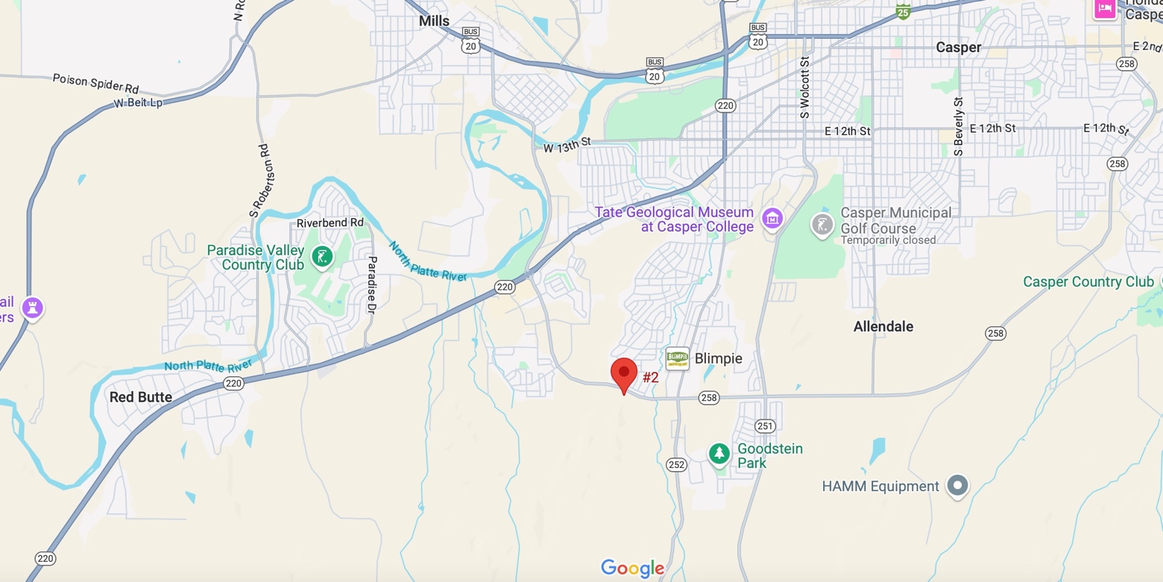

TRAINING COURSE REGISTRATION
Course Applicant: Please complete this form and send via email attachment or regular mail to:

Course Location: | Casper WY
Course Date: | June 13 – 15, 2025
Course Name: | Tracking
Student Name:
Mailing Address:
City:
Prov/State: | Postal Code:
Phone #: | Group/Unit/County:
E-Mail Address:
Current JHPTS Certification | (please check one) (you may double click on the appropriate square and change the default value from Not Checked to Checked)
New Student | Basic Tracker | Apprentice Tracker
Journeyman Tracker |  | Sign Cutter
Deposit Enclosed $100.00 | Tuition Fee Enclosed $____________
Applicant: Please note any requests, dietary needs or questions that you have and wish a response from the contact person.

